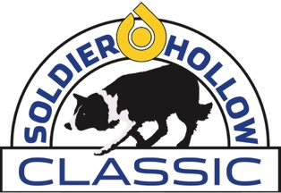

SOLDIER HOLLOW CLASSIC CHANGES DATES!

MEMORIAL DAY WEEKEND - May 24-27, 2024
20th Anniversary Celebration!

The 2023 Soldier Hollow Classic Sheepdog Competition & Festival over Labor Day has been canceled because of construction at the Soldier Hollow Nordic Center. The next Soldier Hollow Classic will be May 24-27, 2024 and will take place over Memorial Day weekend moving forward. This change is exciting and the best way to continue the event and avoid the Labor Day heat. It’s remarkably beautiful at Soldier Hollow Nordic Center in May, and we sincerely hope that you will join us moving forward beginning May 24-27, 2024.

The construction at Soldier Hollow Nordic Center is well underway! New features will include expanded multi-purpose event spaces and indoor restroom facilities. The construction is expected to be substantially complete by February 2024. We expect to see improvements that benefit both spectators and competitors.  Beautiful artist rendering of the new facility at Soldier Hollow Nordic Center. | 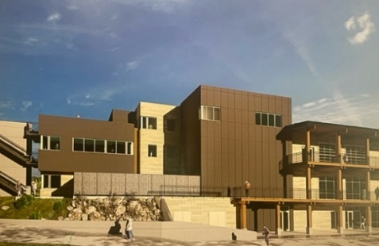

If you are interested in submitting an application for vending (food/beverage, merchandise or information booth), the applications will be posted on the website by October 2023. You may also email Judy Klautt (judy@soldierhollowclassic.com) with any questions.

The best way to stay current on the event is by using our website - www.soldierhollowclassic.com! We hope to see all of you May 24-27, 2024.

