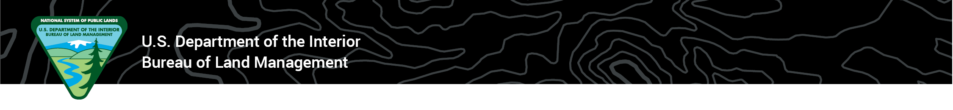 News Release
BLM Washington Office

FOR IMMEDIATE RELEASE Contact: blm_press@blm.gov
March 19, 2020

BLM to temporarily suspend entrance fees on public lands across America

WASHINGTON – After careful consideration and at the direction of Secretary of the Interior David Bernhardt, the Bureau of Land Management will temporarily suspend the collection of all entrance fees until further notice.
As a result, site-specific standard amenity and day-use fees at BLM recreation sites and areas will be waived for the foreseeable future. Other fees, such as overnight camping, cabin rentals, group day use, and use of special areas, will remain in effect.
“I’ve directed the Bureau of Land Management to waive entrance fees at recreation sites and national monuments that remain open. This small step makes it a little easier for the American public to enjoy the outdoors across the 245 million acres of public lands managed by the agency,” said Secretary of the Interior David Bernhardt.
In an effort to support social distancing, the National Park Service and the U.S. Fish and Wildlife Service and other states and municipalities recently made similar announcements to temporarily suspend entrance fees at parks, refuges and other public recreation sites.
“Our vast public lands overseen by the Department offer special outdoor experiences to recreate, embrace nature and implement some social distancing.” Secretary Bernhardt continued.
At a majority of BLM-managed locations where it is currently possible to adhere to public health guidance, outdoor spaces remain open to the public, while many facilities will be closed.
The Department of the Interior and BLM continue to urge visitors to do their part when visiting your public lands to follow CDC guidance by maintaining a safe distance between yourself and other groups; washing your hands often with soap and water for at least 20 seconds; avoiding touching your eyes, nose, and mouth; covering your mouth and nose when you cough or sneeze; and most importantly, staying home if you feel sick.
Specifically, the CDC recommends high-risk populations, such as the elderly and people with underlying conditions, take extra precautions to be best protected against the spread of coronavirus.
Updates about the BLM response to the coronavirus will be posted on www.blm.gov. Please check with individual field and district offices and visitor centers for specific details about operations in your area.

BLM-managed public lands offer a wide array of recreational opportunities, including hiking, hunting, fishing, camping, mountain biking, horseback riding, boating, whitewater rafting, off-highway vehicle driving, rock climbing, and more. Americans make approximately 67 million visits annually to BLM-managed lands, supporting approximately 48,000 jobs nationwide and contributing almost $7 billion to the U.S. economy.

For more information on recreation opportunities on BLM-managed public lands, visit https://www.blm.gov/programs/recreation or www.recreation.gov
-BLM-
The BLM manages more than 245 million acres of public land located primarily in 12 Western states, including Alaska. The BLM also administers 700 million acres of sub-surface mineral estate throughout the nation. In fiscal year 2018, the diverse activities authorized on BLM-managed lands generated $105 billion in economic output across the country. This economic activity supported 471,000 jobs and contributed substantial revenue to the U.S. Treasury and state governments, mostly through royalties on minerals.

